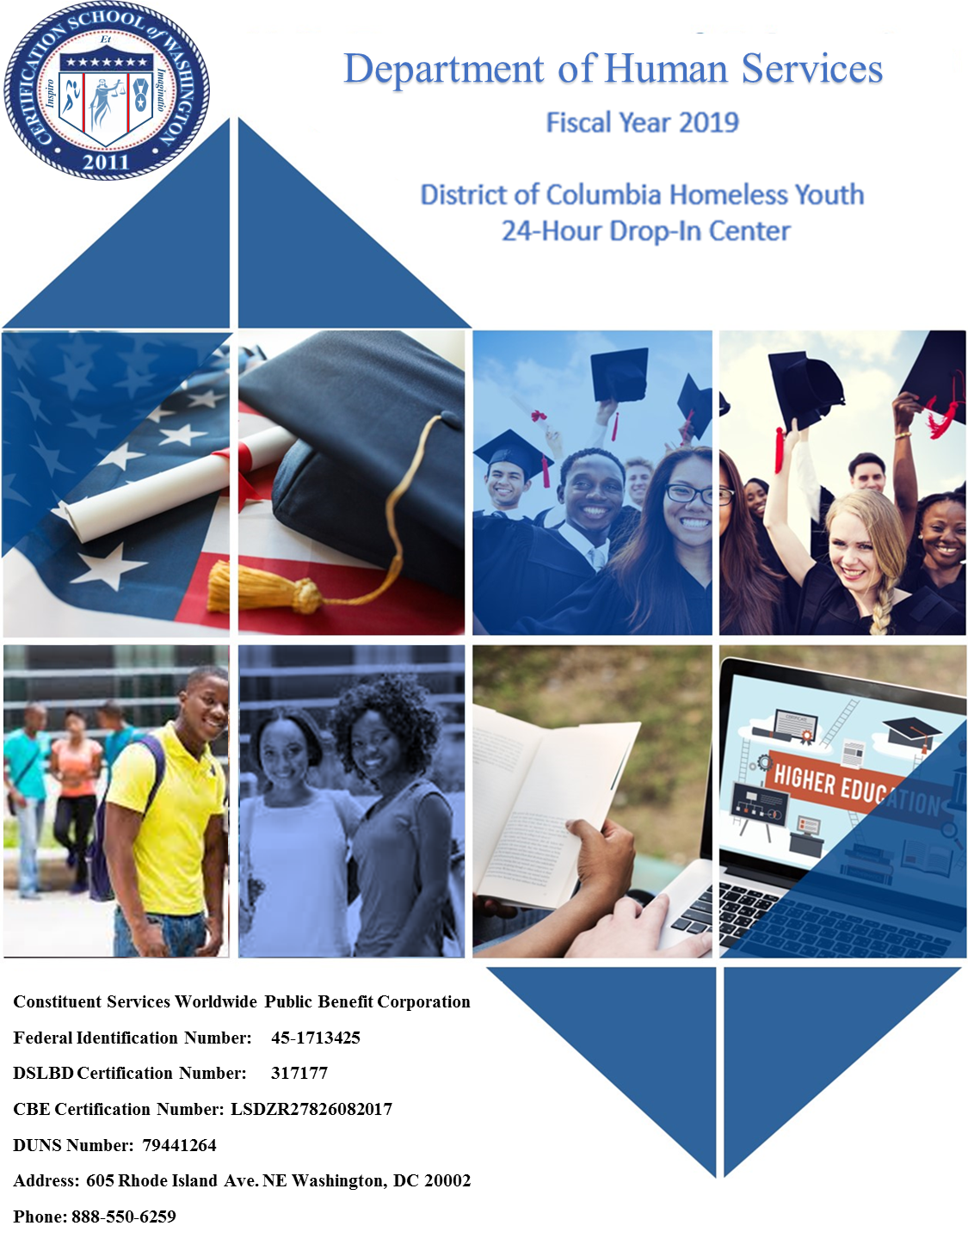

Certification School Worldwide

**www.cswPbc.com**

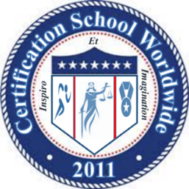





THE CERTIFICATION SCHOOL WORLDWIDE

SERVICES AVAILABLE

* **WORK READINESS TRAINING**

We provide a user-friednly online platform that containing courses in a wide range of subject areas.

* **OCCUPATIONAL TRAINING**

As a certified One Stop Center, CSW offers staffing solutions that provide businesses with employees who are skilled and ready to work

* **INTERNSHIPS & JOBS**

As a certified One Stop Center, CSW offers staffing solutions that provide participants internships leading to placement with employers.

* **MANAGEMENT CONSULTING**

Professional and management consulting for an array of short duration projects and trainings.

We are proud to announce that Certification School Worldwide Public Benefit Corporation (CSW) was approved on March 15, 2019 by the Office of the State Superintendent of Education’s (OSSE) Higher Education Licensure Commission (HELC) to provide post-secondary adult education. The approval also formally recognizes the creation of the Certification School Worldwide division of CSW. We look forward to providing new trainings that advance our mission to “Re-inspire the Dream” beginning May 13th. We would like to thank everyone for their support during the 9-month licensing process and hope to work together in the near future. The Certification School Worldwide is licensed to offer the following certificate programs and training courses leading to certification examination.

**605 Rhode Island Avenue, NW Washington, DC 20001 Tel 888.550.6259 Fax 888.551.6593**

